The Zone Blitz
The zone blitz was started in the early '90s as a way to give the defenses a method to pressure offenses without the high risk of playing man-to-man coverages. Zone blitzes are easy to disguise because they look like base zone coverage to the offense at the line of scrimmage.
Another confusing aspect of the zone blitz to the offense is the fact that the defense exchanges responsibilities. The defense blitzes players that the offense anticipates will drop into pass coverage. The defense then replaces those blitzers with defensive players that the offense has accounted for as rushers.
Standard 2-deep zone
To understand the zone blitz scheme, you must first look at how a standard defense divides the field and determines who will drop into pass coverage and who will rush the passer.
In the drawing below, we show a standard 4-man rush with seven defenders being allocated for pass defense. This is a basic 2-deep pass coverage, meaning the defense divides the deep pass zones into two halves of the field with a safety in coverage for each. When playing a 2-deep zone, the remaining droppers (the two corners and three linebackers) divide the underneath, or shallow, areas of the field into equal fifths. The offense anticipates that the linebackers and corners will drop into pass coverage and that the two ends and the two tackles will be the pass rushers.

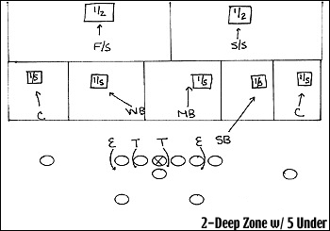

Standard 3-deep zone
In the drawing below, the defense is playing another standard zone called a 3-deep zone. As you can see below, the defense has decided to defend the deep area of the field by dividing it into thirds with each zone covered by a defender. When playing a 3-deep zone, you take the four remaining pass droppers and divide the underneath pass zones into fourths. A standard 4-man rush with the two ends and two tackles remains.

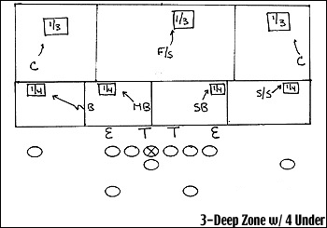

2-deep zone with WLB and DE exchange
The first zone blitz we will discuss involves the switching of responsibilities in the basic 2-deep zone coverage. In this zone blitz, the weakside linebacker blitzes through the A gap and the defensive end -- from a three-point stance -- drops into pass coverage. This confuses the offense because the defensive end in the three-point stance has been identified as a rusher. The offense expects the defensive end to rush and allocates the offensive tackle to block him. Not only is the offensive line handicapped by the offensive tackle's wasted assignment on the DE, but by bringing the weakside linebacker the running back is forced to stay in and not release into a pass route, even though it is a simple 4-man rush.

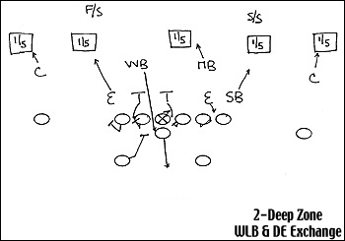

2-deep zone with MLB and nose tackle twist
The next 2-deep zone blitz involves bringing the mike or strongside linebacker from the tight end side. In the figure below, the mike linebacker plugs his A gap strong and the nose tackle twists around. The defense simply replaces the mike linebacker's pass drop with the weakside linebacker and the defensive end takes the weakside linkebacker's pass drop if it is pass.

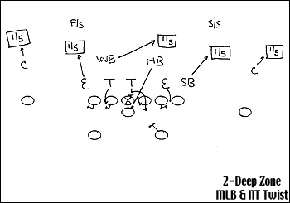

Strongside linebacker zone blitz
The next zone blitz is the most common in football today. Every week when watching a college football game, you will see some form of this. This strongside linebacker zone blitz becomes even more complicated to the offense because the defense shows a 2-deep zone prior to the snap of the football. The offense anticipates that the linebackers will drop into their fifths in pass coverage. However, the defense drops down into a 3-deep zone on the snap choosing to divide the field into four underneath pass zones and three deep ones. The strong safety plays the outside fourth. The weakside linebacker takes the mike's drop in his fourth. The nose tackle, if it is a pass play, drops from a three-point stance and takes the will linebacker's fourth. The defensive end moves from a three-point stance to take the outside fourth. This scheme allows the strongside outside linebacker and mike to blitz when the offense doesn't expect it.

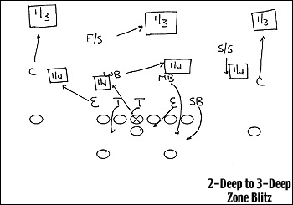

MLB and WLB cross zone blitz
The next 3-deep zone blitz involves blitzing both inside linebackers from a formation that appears to be a 2-deep zone (called a 2-deep hide). The mike linebacker blitzes his A gap and the weakside linebacker loops around behind the mike linebacker in the B gap. The free safety actually drops down on the snap as a linebacker and plays the shallow one-third drop. As you can see in this diagram, the defense has chosen to play a 3-deep zone and only deploy three underneath coverage men. The defense has chosen to give up one area of underneath coverage.

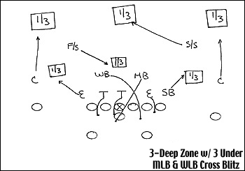

Strong safety and MLB zone blitz
You can also blitz one of your safeties from a 2-deep look to confuse the offense. In this particular blitz, it is the strong safety who comes up and blitzes the B gap along with the mike linebacker who blitzes the A gap. The defense once again plays a 3-deep and 3-underneath coverage giving up an underneath zone.

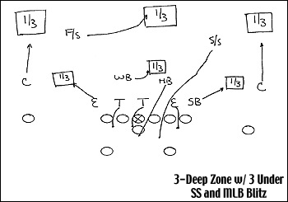

Summary
As you can see, there are unlimited combinations of zone blitzes. The idea is to confuse the offense's identification of who the rushers and pass defenders are. It plays havoc with the offense's count system in determining blocking assignments.
The offense counters the zone blitz with ways to identify if it is coming and where it is coming from. They may utilize different formations and change the snap count so that the defense tips of its plan prior to the snap.
The zone blitz has become a big part of college and professional football. The Michigan-Notre Dame game this Saturday will be great opportunity to watch zone blitzes in action. Both teams have extensive zone blitz packages.

